Practical - 14

Practical Title: Admin Dashboard with Role-Based Access Control, Dynamic Menu, and Audit Log

Develop an admin dashboard that displays user statistics, student count, event count and latest registrations. Restrict access to admin users only and show dynamic menu options based on role.

Theory:
- Are dashboard values loaded dynamically from the database?

Yes. PHP executes SQL COUNT(*) queries to display the current number of users, students, and events.

- Is access restricted to admin users?

Yes. PHP sessions check whether the user is logged in and has the admin role before displaying the dashboard.

- Are role-based menus working?

Yes. Admin users see administrative links, while student users see only student-related links.

- Are important admin actions recorded in audit_logs?

Yes. Opening the dashboard inserts an action, the admin's user ID, and the date and time into the audit log.

Implementation
PHP functions and methods used

Function / method Purpose
session_start() User session start kare chhe.
new mysqli() MySQL database sathe connection banave chhe. connect_error Database connection error check kare chhe. prepare() SQL query safely prepare kare chhe. bind_param() Query ma values bind kare chhe.
execute() SQL query execute kare chhe.
password_verify() Enter karelo password stored hash sathe check kare chhe.
password_hash() Password ne secure hash ma convert kare chhe.

header() Redirect karva mate.
session_destroy() Session destroy kari logout kare chhe. htmlspecialchars() HTML output ma unsafe characters escape kare chhe. COUNT(*) Total users, students ane events count kare chhe. fetch_assoc() Database result ne associative array ma lave chhe.

Evidence of Work (Screenshots)

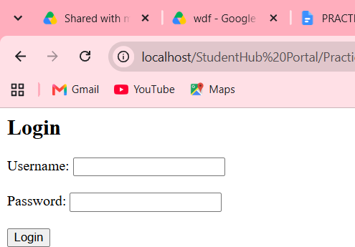

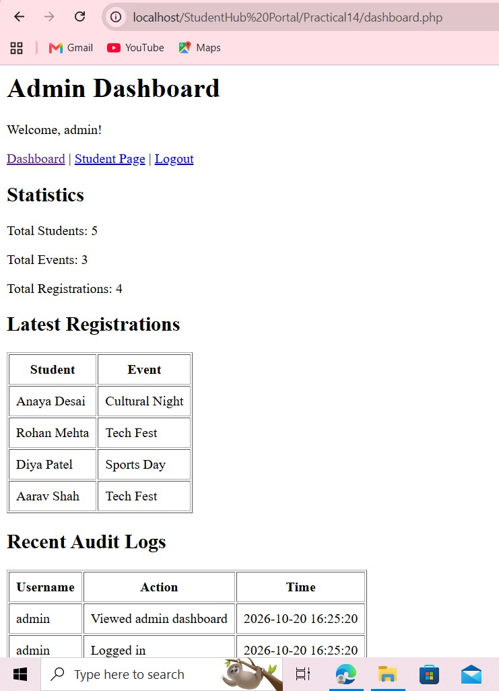

GitHub Repository Link: https://github.com/shahmahi0717/Student-Hub-Portal

Challenges Faced:
    - Connecting PHP with the MySQL database.
    - Fetching counts using SQL queries.
    - Restricting the dashboard to admin users.
    - Displaying different menus according to user roles.
    - Recording admin activities in the audit log.

Learning Outcomes:
I learned how to create an admin dashboard using PHP and MySQL.

I learned to fetch dynamic statistics using SQL queries, restrict access using role-based access control, display menus according to user roles, and record important activities in an audit log.

Faculty Remarks:



